Mini Assignment – 1 Lung Caner

Task 1: Write a function that removes duplicate rows, ensures correct data types for numerical and date columns and converts all ‘yes’/ ‘no’ type fields into 1/0 format.
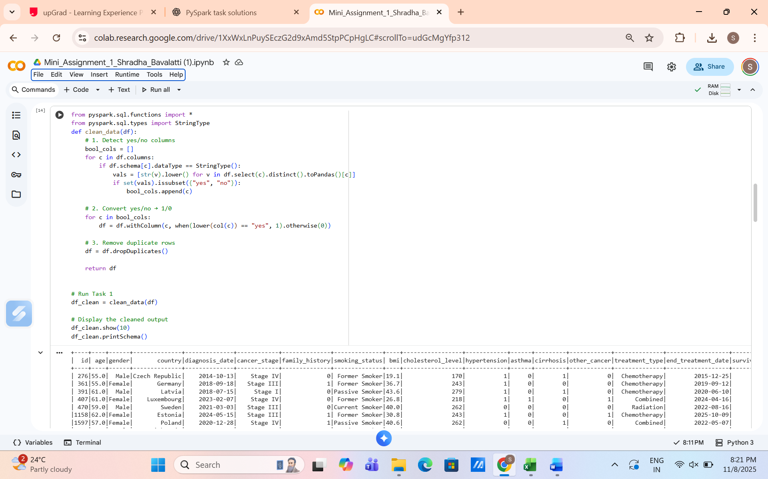

The clean_data function performs basic data cleaning on the patient dataset. It first identifies columns containing only 'yes'/'no' values and converts them into numerical format (1 for 'yes', 0 for 'no') for easier analysis. Next, it removes any duplicate rows to ensure data integrity. Finally, the cleaned DataFrame is returned, ready for further analysis. The show() and printSchema() functions are used to inspect a sample of the cleaned data and verify column types.

Task 2: Write a function that adds a new column, treatment_duration_days, which calculates the number of days between the diagnosis and the end of treatment. Then, return the average treatment duration for each treatment type.
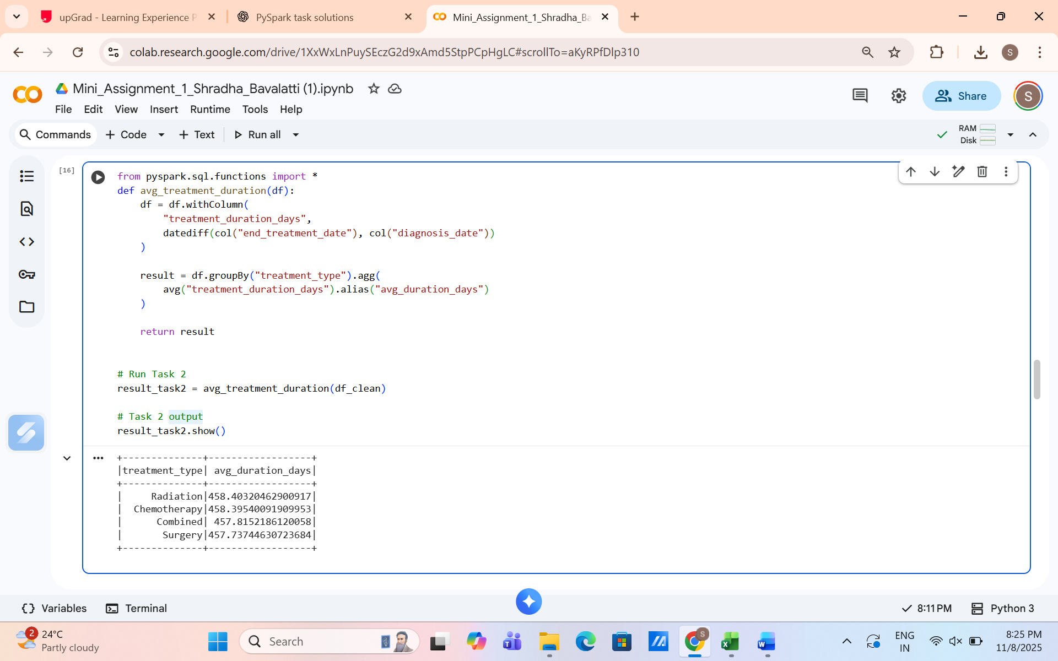

The avg_treatment_duration function calculates the duration of treatment for each patient by computing the difference in days between end_treatment_date and diagnosis_date, storing it in a new column treatment_duration_days. It then groups the data by treatment_type and calculates the average treatment duration for each group. The resulting DataFrame provides a clear view of how long, on average, patients undergo each type of treatment.

Task 3: Write a function that returns the smoking_status group with the highest survival rate.
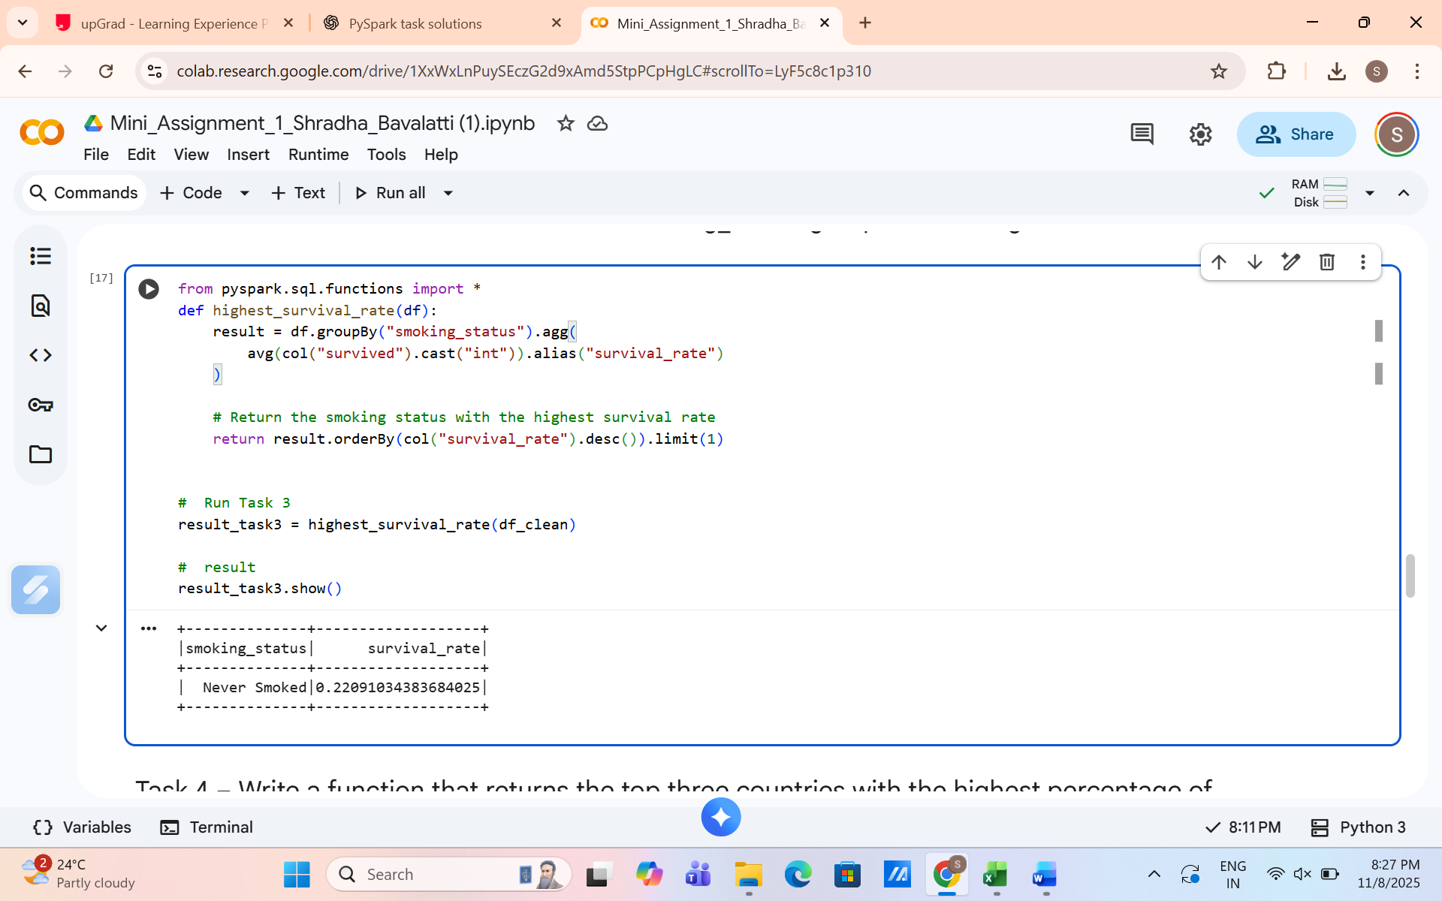

The highest_survival_rate function calculates the average survival rate for each smoking_status group by converting the survived column to numeric format and computing the mean. It then identifies the smoking status with the highest survival rate by ordering the results in descending order and selecting the top entry. This helps in understanding which smoking group has the best patient outcomes.

Task 4: Write a function that returns the top three countries with the highest percentage of patients diagnosed in Stage IV.
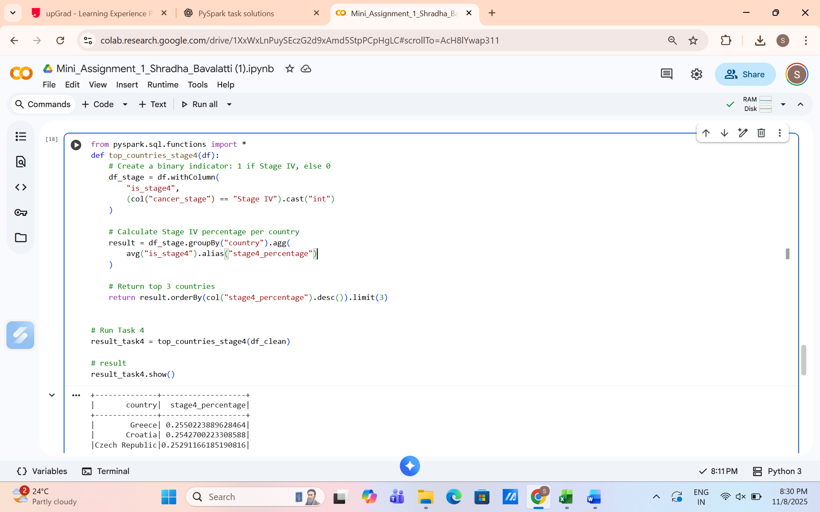

The top_countries_stage4 function identifies patients diagnosed in Stage IV cancer by creating a binary indicator column (is_stage4). It then calculates the percentage of Stage IV cases for each country by averaging this indicator and returns the top three countries with the highest percentages. This helps highlight regions with a higher prevalence of advanced-stage diagnoses.

Task 5: Write a function that filters patients who:
- Are male
- Diagnosed in Stage III or IV
- Have a family history of cancer
- Are current smokers
- Have a BMI > 30
- Survived
Return the average age and the percentage of these patients who had hypertension.
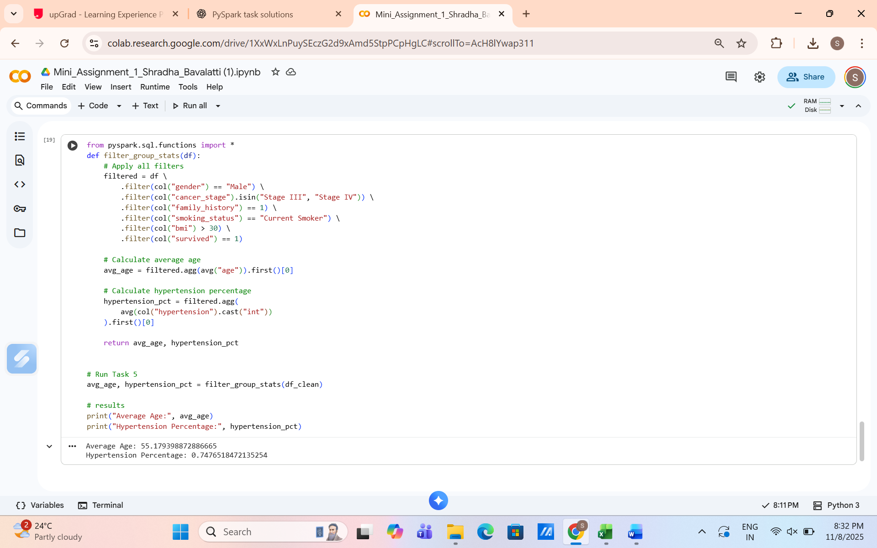

The filter_group_stats function filters patients based on multiple conditions: male gender, Stage III or IV cancer, a family history of cancer, current smoking status, BMI greater than 30, and survival. After filtering, it calculates two key statistics: the average age of this patient group and the percentage who have hypertension. These metrics help summarize the health profile of high-risk, surviving patients.

Assumptions made:
  - Date columns (diagnosis_date, end_treatment_date) are in valid date formats suitable for PySpark processing.
  - All yes/no fields represent binary attributes and can be converted to 1/0.
  - Column names in the dataset match the names used in the code (e.g., treatment_type, smoking_status, cancer_stage, survived).
  - Cancer stages follow the standard format: Stage I, II, III, IV.
  - The survived, hypertension, and family_history fields are treated as binary indicators (1 = yes, 0 = no).
  - Missing or inconsistent data is assumed to be minimal and does not affect the analysis.
  - Treatment duration is calculated as the difference between end_treatment_date and diagnosis_date.

